Problem statement:-How store a simple text or a number in your mobile, so the user can refer to it later.

Solution:-A simple Notes app can store all the text or numbers or even your scripts. With title and subtitles(if necessary).

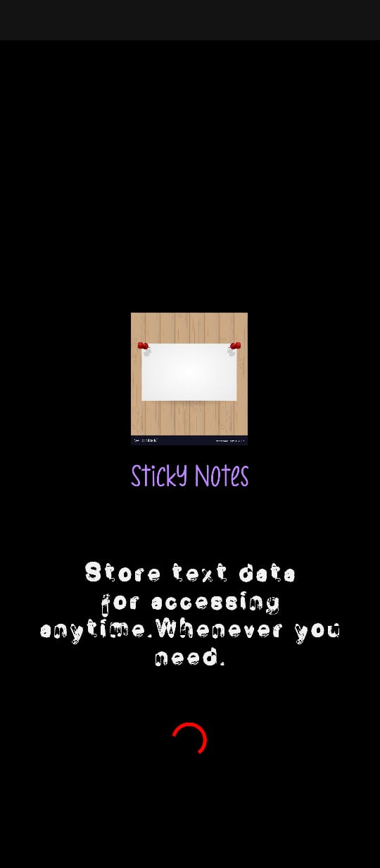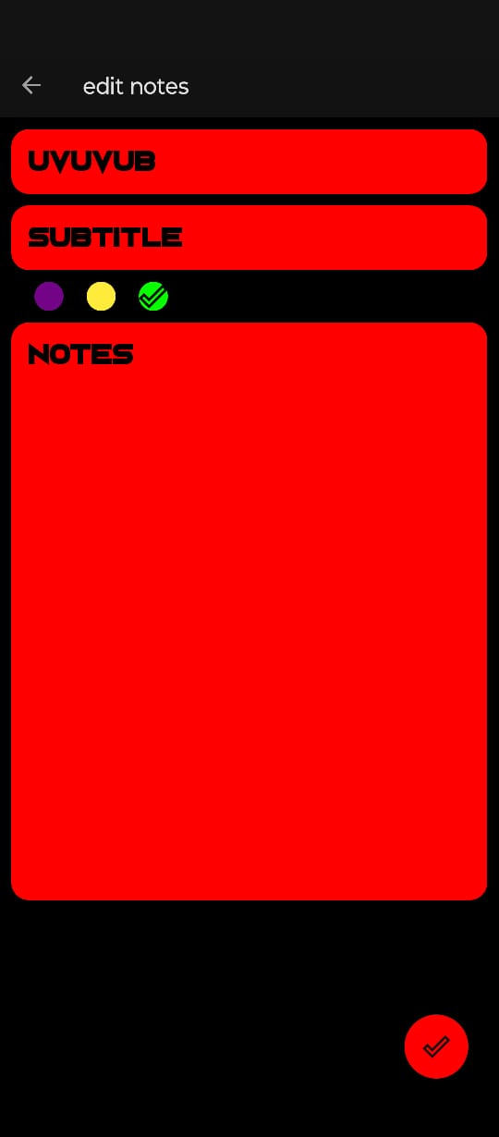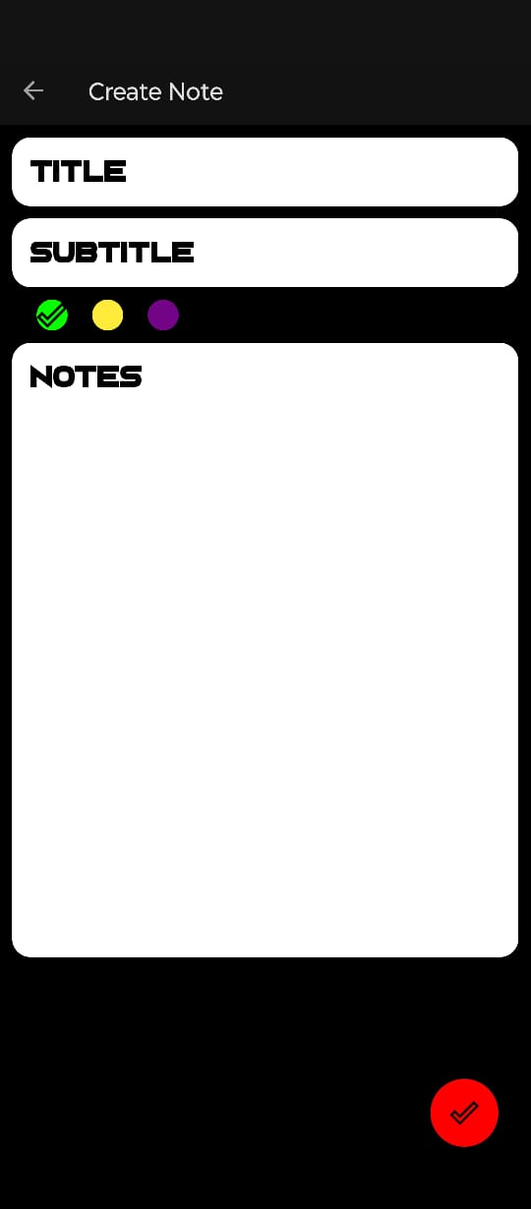

Functionality:-This app has almost all of the simple functions a typical notes app can offer.

The app has a create and edit functions, with

white-black and red-black themed UI.

You can create your notes in the white-black themed UI layout.

You can also edit your notes in red-black themed UI layout.

Concepts:-This app uses jetpack compose NavController.

The navigations are:

Home Fragment to create Fragment.

Create fragment to home fragment.

Home Fragment to edit fragment.

Edit fragment to Home fragment.

It also uses view model.(All the code in the link below)

Application link:- <https://github.com/Redsu1951/Notes-App>

Youtube link:- <https://youtu.be/MGeWxdGZ_dU>

Future Scope:-Notes app is an essential app which comes with Stock android or any other skinned android software on mobile.

We tend to use notes book to store the data. But it may be unreliable sometimes. So a virtual note book is a lot better to store the data.

We can even add some other functions like, filter and search.

Thank You